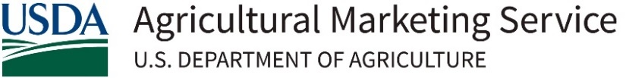
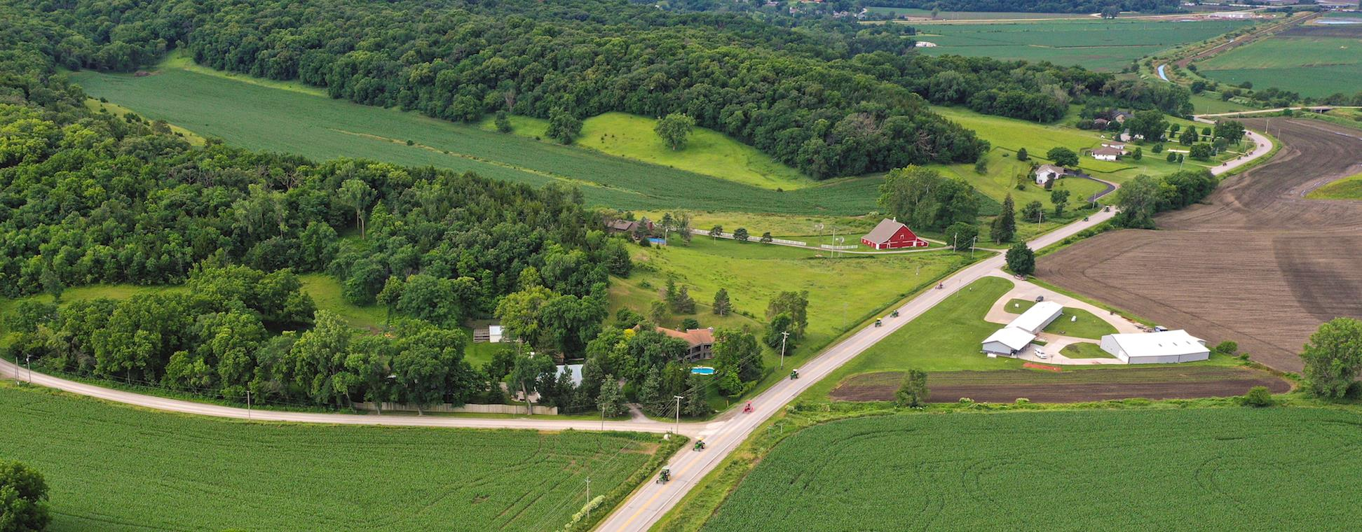
Plant Survey – Customer Reference
September 2025

The USDA Plant Survey Inspection Program, operated by the Agricultural Marketing Service (AMS) Dairy Program Grading Branch (DGB), is a voluntary inspection service that evaluates dairy manufacturing facilities to ensure compliance with established quality, sanitation and operational requirements outlined in 7 CFR 58 Subpart B, General Specifications for Dairy Plants Approved for USDA Inspection and Grading Service. The Plant Survey (PS) Manual is intended to provide information and clarification related to industry’s participation in the Plant Survey Inspection Program.
Key Changes
Non-Conformance Rating
Non-Conformance ratings have been changed from alphabetical ratings such as A, B, C, D or E to language utilized and accepted in the dairy industry.
- Critical Non-Conformance: An imminent health hazard caused by a condition that presents a biological, chemical, or physical food safety or food defense hazard that is not prevented, eliminated, or reduced by a subsequent process, practice, step or procedure; or that may cause food to be unsafe for consumption or otherwise adulterated.
- Major Non-conformance: A condition, practice, step or procedure that, in itself, does not present a food safety, food defense or imminent health hazard but has the potential to affect food safety or the product’s intended use due to loss or lack of verifiable control.
- Minor Non-conformance: A condition, practice, step or procedure that is not in accordance with food safety and defense requirements and does not meet the criteria of a Critical or Major Non-Conformance.
Plant Status Assignment
Plants that are inspected will be assigned one of the following status designations; Approved, Probationary, Ineligible or No Status Assigned. These statuses reflect a plant’s compliance with USDA’s General Specifications and determine eligibility for USDA grading and certification services.
- Approved Status: The plant fully meets USDA General Specifications. No Critical or Major non-conformances are identified during the inspection.
  - Eligible for all USDA grading services
  - Listed on the USDA Dairy Plants Surveyed and Approved for USDA Grading Service List
  - No follow-up inspection required unless non-conformances develop
- Probationary Status: The plant has non-conformances that, if not corrected, would result in the Ineligible status being assigned. One (1) Major non-conformance or multiple Minor non-conformances are identified.
  - Temporary status from 10 days to 3 months
  - Re-inspection required
  - May still participate in USDA grading (unless otherwise specified)
- Ineligible Status: The plant has at least one (1) Critical non-conformance, or two (2) or more Major non-conformances.
  - Not eligible for USDA grading services
  - Plant and/or affected product codes are removed from USDA’s approved listings
  - Correction of non-conformances before the end of the inspection may prevent Ineligible status, but Probationary status will be assigned.
  - Products manufactured by the plant since the last inspection will be considered Ineligible.
    - Unless the plant provides documents that identify a date after the last survey that provides sufficient evidence indicating safe and quality conformance with the General Specifications with supporting preventive maintenance, the Ineligible will be limited to the date identified in the documents.
- No Status Assigned: Assigning a plant status is not appropriate or possible. No Status Assigned examples are as follows:
  - During the initial survey, the plant does not meet USDA’s General Specifications.
  - Plant management requests inspection of only part of the plant, and that portion fails to meet General Specifications.
  - The plant changes or removes a USDA product code.
Rolling Plant Survey Inspection
This is an alternative optional inspection method available to resident grading service facilities to streamline the equipment inspection process. This option will shift the plant inspection process to working with the plant’s cleaning and maintenance schedules, minimizing downtime and inspection costs while increasing efficiency and time management.
- Conducted between semi-annual plant surveys
- Reduces downtime and inspection costs
- An inspector is notified when equipment is down for cleaning or regular maintenance
- Recommendations are included in final periodic plant survey report
- Weekly cursory inspections continue alongside rolling surveys
Source Ingredient Acceptance
The USDA Dairy Program will accept all dairy products and ingredients from USDA-approved sources or Grade A bovine dairy products and ingredients from U.S.-based domestic plants on the Sanitation Compliance and Enforcement Ratings of Interstate Milk Shippers (IMS) List for Grade A Plants with product codes equivalent to USDA DGB product codes.
A plant may request that source ingredients derived from domestic Grade A products without an IMS-listed product code be reviewed on a case-by-case basis for acceptance by the National Field Director or designee as an approved source.

Contact and Support
For questions about the Plant Survey Program:
USDA AMS Dairy Program
National Field Office
650 E Diehl Rd, Suite 100
Naperville, IL 60563
Phone: 630-437-5073
Fax: 630-437-5060
Email: DairyNFO@usda.gov

